Exercise 1 : Setting up JUnit

1.1 Calculator.java

public class Calculator {

public int add(int a, int b) {
return a + b;
}

}

CalculatorTest.java

import static org.junit.Assert.assertEquals;
import org.junit.Test;

public class CalculatorTest {

Calculator calculator = new Calculator();

@Test
public void testAdd() {
assertEquals(30, calculator.add(10, 20));
}
}

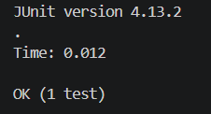

Exercise 3 : Assertions in JUnit

AssertionsTest.java

import static org.junit.Assert.*;
import org.junit.Test;

public class AssertionsTest {

@Test
public void testAssertions() {

// Assert equals
assertEquals(5, 2 + 3);

// Assert true
assertTrue(5 > 3);

// Assert false
assertFalse(5 < 3);

// Assert null
assertNull(null);

// Assert not null
assertNotNull(new Object());
}
}

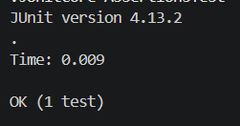

Exercise 4 : Arrange-Act-Assert (AAA), Pattern, Test Fixtures, Setup and teardown Methods in JUnit

Calculator.java

public class Calculator {

public int add(int a, int b) {
return a + b;
}

}

AAATest.java

import static org.junit.Assert.*;
import org.junit.After;
import org.junit.Before;
import org.junit.Test;

public class AAATest {

private Calculator calculator;

@Before
public void setUp() {
calculator = new Calculator();
System.out.println("Setup: Calculator object created.");
}

@After
public void tearDown() {
calculator = null;
System.out.println("Teardown: Calculator object destroyed.");
}

@Test
public void testAdd() {

// Arrange
int a = 10;
int b = 20;

// Act
int result = calculator.add(a, b);

// Assert
assertEquals(30, result);
}
}

